When the offer first came, Chris and I didn’t know how the children would respond. Being given the scholarship to attend the Messiah Conference in Pennsylvania was jaw dropping. Everything would be paid for once we arrived on campus. The only thing we would need to cover was the gas and food traveling expenses. And of course, the loss of pay for an entire week was a big concern. What to do?

Changes have been so prevalent in our lives for the past 2 years. We even held off leaving our “church” for just the bible study ministries in order to give the children some normalcy and stability during that time. Learning to look at the Bible through the eyes of the Jewish people has been a challenge. Our children are older now. They are “set in their ways”. Going to this conference would be a week of “different” with no escape! However, we were meet by the children with excitement over the possibility. Chris and I both felt it was needed and a perfect opportunity to give the entire family some grounding.

The next day came and Chris examined Christopher before he left for Life Care. No complaining all day. He couldn’t move it much more than the evening before, but had quickly figured out how to move the track pad on his computer over so he could use his left hand to work on his movie script!

I called our insurance to find out who was in network, just in case. Chris called around 1:30 PM to tell me he would wait in Cleveland and I should just bring him on for an x-ray. The receptionist told us what had to be paid to see the doctor and what an x-ray would cost. The triage nurse took our info and we waited in the room. The nurse practitioner felt around and ordered his x-ray. You would have been proud of me. I treated this son, who is WAY taller than me, like an adult and let him go to the x-ray by himself. The door opened and he reentered with a sling on his arm. “It’s broken, “ I said. “I don’t know. The guy just gave it to me, “ he replied. Later on I got the whole story. The tech took one x-ray, brought the sling to him and then took 3 more x-rays. The x-ray cost quoted to Chris just tripled.

It was a beautiful afternoon in late May as I went to check my laundry hanging on the line. I decided I would brave the mosquitoes and sit for a while at the table in the front yard. Moments later, Chris drove up. He was returning from Life Care. He sat down across the table from me. “Do you have any revelations about the Messiah conference?” he asked. We discussed a few things and that he thought we should go ahead with the registration. Later that afternoon I sat down at our computer. In my inbox were 2 emails from people telling me they had been praying for our decision. One even wanted to give us some money on gas. I typed thank you replies and told the 3 oldest “bye” as they left to meet a friend in Cleveland for a youth event.

Gideon and I had an uneventful few hours while we awaited Chris’ return from mowing a yard and the Hardees burgers he was to bring us for supper. A few minutes after 7 PM, we went outside to bring in my laundry. I thought about the fact that I didn’t have my cell phone but knew I would only be outside a few minutes. Upon returning inside the phone rang. “Where have you been?” came Chris’ distressed voice. “I’m headed home to get you. Susan called and it sounds like Christopher has dislocated his shoulder.” It was 7:14 PM by my clock. The activities had begun at 7 PM. “Have we made the wrong decision about the conference?” My thoughts began to churn.

And so it began. The phone calls back and forth. “Everyone here thinks he just bruised it since he isn’t in agony, crying on the ground. We are heading home,” said Susan. We called back to speak directly to Christopher. He was calm and told us some of what happened. We decided to wait. And wait we did. He didn’t ask for anything for pain, although I did give him some Tylenol and stayed up until midnight so I could give him ibuprofen. He slept restfully on the couch that night.

“Do you think we made the wrong decision about the conference?” I asked Chris before bed. “No.” came his reply. By this point I was feeling pretty confident we had not either. I felt pretty sure that Satan wasn’t happy with our decision and was working hard to change it.

##### 183 Parker RD Benton, TN 37307 (423) 338-5545 sctreehouseproductions.weebly.com

The Stewart Six

Chris, Penny, Susan, Christopher, Jonathan, and Gideon

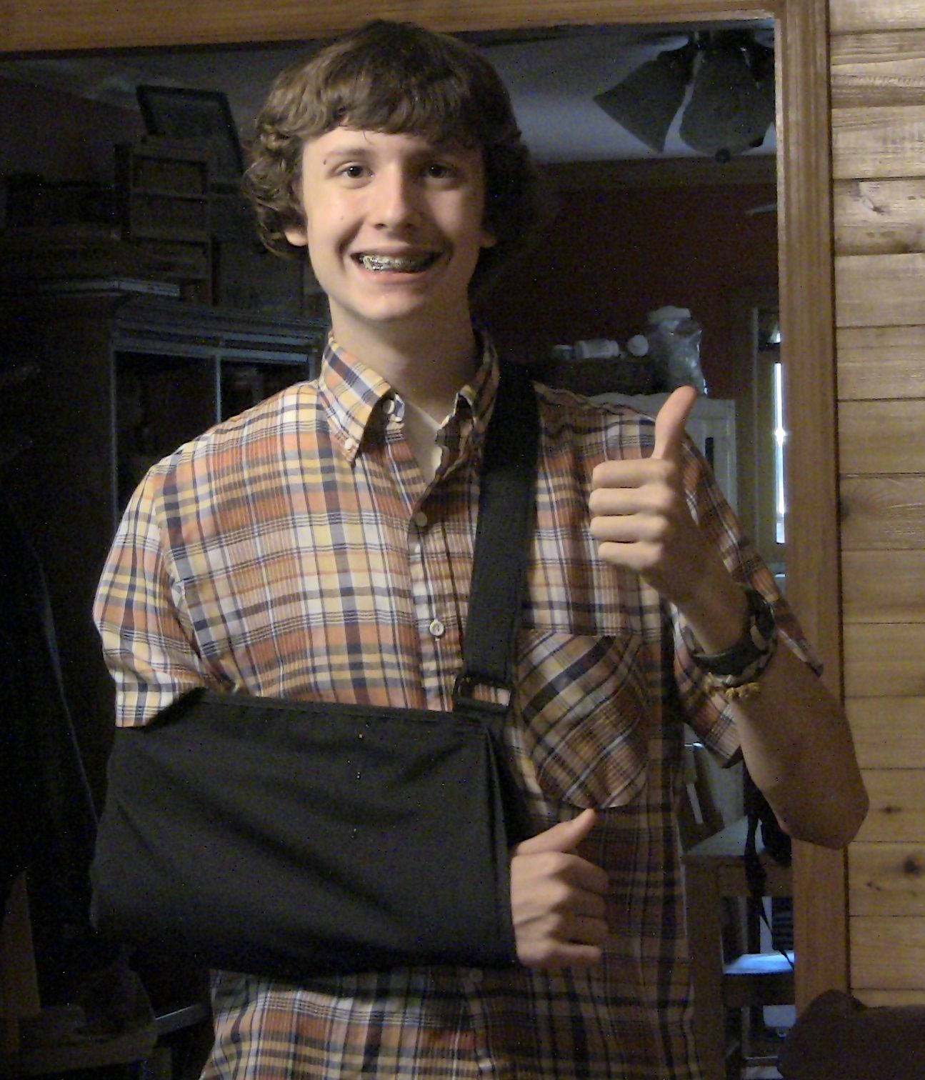

**Update: Christopher is healing amazingly well. The doctor said it couldn’t look any better. He should be able to start some rehab after we return from PA.**

**Prayer Updates:**

**\*Our family asks that you covet to pray with us about our financial situation. Please pray that the LORD will provide Chris with the job situation he needs that will allow him with not only the time he needs to study and prepare for the teachings he leads, but also meet our monthly bills.**

**\*Our Cleveland Bible Study is doing really well. We average 26 each time we meet (twice a month). We have also had 2 additional meetings lately, one for prayer only and one for fellowship. Please continue to pray for this group. One of the amazing things about it is that each family represented has a male leader attending. There is great potential for spiritual leadership and growth among these families.**

“He definitely broke his clavicle. It’s a clean break. He’ll need to see an orthopedic sports medicine doctor to have it set” the Nurse Practitioner said as she opened the door. “I can’t believe he did this last night and is just now coming in.” “And just standing there like that!” We had suddenly become the talk of the clinic. Apparently a hangnail was the most exciting thing that had happened in a while! The x-ray tech was in the hall and told Christopher “Good Luck” as we exited. We were still clueless.

Downtown Chattanooga. McCallie Street. 2:30 PM on a Friday afternoon. Yippee! The Cleveland clinic didn’t have an open appointment for another 8 days. We would have to go to Chattanooga to have the bone set. “Who do you want to go with you?” asked Dad “Mom or I?” You could see the nervousness on Christopher’s face as he responded, “I don’t know.” “You won’t make one of us mad” I said “or would you rather have both of us? Dad for strength and me for gentleness” I laughed. He got a silly little boy look on his face. Sometimes I forget what those use to look like. He is so tall and responsible and hard working. “That sounds good” he replied.

We saw a terrific doctor that day; he was kind and gentle with Christopher. Unfortunately, his shoulder needed surgery. No wonder everyone was so amazed at the clinic the day before. The Cleveland clinic fit us in on Tuesday to see the surgeon. Dr. Grebner scheduled him for surgery on Thursday. Even though Christopher and I have a funny story concerning him, we began to feel like the delay was just so this doctor could be the one to perform the surgery. As we left the hospital to come home, Christopher had a cool x-ray printout showing a titanium plate and six screws repairing his clavicle. Whew, what a ride!

Needless to say, the conference trip plans had been set-aside for a while. However, we are still planning to attend. We will leave on June 30 and return July 7. The trip will take 10 hours, plus stops. Please remember our family as the LORD brings it to your mind over those few days. There are so many meetings and activities to choose from…and none are repeated throughout the week! We will attend classes during the day with worship services every night. July 4th also offers an optional all day concert activity. The three older children have “youth” activities and Gideon has some preteen ones as well. And, we will be about 30 minutes from Gettysburg on the 150th anniversary of the Battle of Gettysburg. Hopefully, we can at least drive by or through the cemetery before heading for home. Jonathan is just pretty excited that we will be in Pennsylvania on the 4th of July. He thinks that is cool! We are also looking forward to the Sabbath service on Saturday. Susan and I may even take some Jewish dance classes…stop laughing…I know I’m not graceful, but stop laughing! Next month I hope to have some photos and wonderful tales to tell you (just not ones of me dancing!)

### Family Happenings